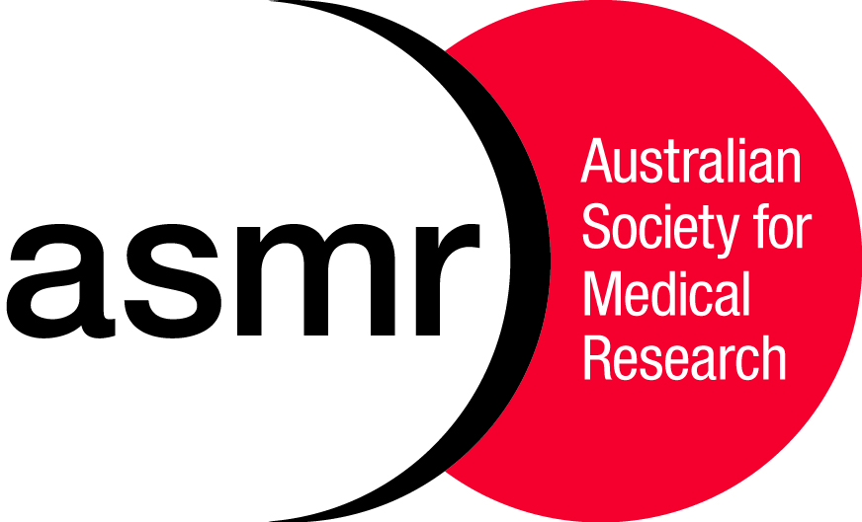
The Australian Society for Medical Research
ASMR Medical Research Week® May 30th – June 8th, 2018

Media Alert Embargoed until 8:30pm Friday June 1st, 2018

CELEBRATING AUSTRALIAN HEALTH AND MEDICAL RESEARCH
QUEENSLAND HEALTH AND MEDICAL RESEARCH AWARD WINNERS ANNOUNCED
ASMR MRW® Gala Dinner, Hillstone St Lucia

Dr Philip Mosley, QIMR Berghofer, Winner of the Postgraduate Student Researcher Award
The Site of Stimulation Moderates Neuropsychiatric Symptoms after Subthalamic Deep Brain Stimulation for Parkinson’s Disease
Deep brain stimulation of the subthalamic nucleus is an advanced therapy that addresses the motor symptoms associated with Parkinson’s Disease. However, this therapy has been associated with damaging neuropsychiatric symptoms such as impulsivity and hypomania. Researchers were able to identify specific subthalamic regions associated with neuropsychiatric impairment and found they could predict the development of clinically-significant symptoms with high accuracy.

Dr Tania Rivera Hernandez, The University of Queensland, Winner of the Early-Career Researcher Award
An experimental group A Streptococcus vaccine that reduces pharyngitis and tonsillitis in a non-human primate model
Pharyngitis caused by group A Streptococcus is linked to the development of the autoimmune disease, acute rheumatic fever. Repeated episodes of acute rheumatic fever can trigger rheumatic heart disease, a major cause of heart failure and stroke in developing countries. Using non-human primates, Dr Rivera Hernandez and colleagues have evaluated the experimental vaccine called Combo5 against group A Streptococcus induced pharyngitis. A reduction in pharyngitis and tonsillitis symptoms were found in vaccinated primates, warranting further investigations to evaluate this vaccine clinically.

Dr Michael Smout, James Cook University, Winner of the Mid-Career Researcher Award
Saving diabetic feet with supercharged wound healing
Chronic wounds commonly affect diabetic patients and often lead to limb amputation, contributing to the ballooning healthcare costs associated with diabetes. Having identified a protein Ov-GRN-1, as the parasitic wound healing protein that promotes wound repair of hosts during infection, Dr Smout and his research team have created and patented synthetic Ov-GRN-1 derived peptides as potential wound healing treatments. Initial preclinical studies have shown that these peptides are superior to Regranex, the only FDA approved biological treatment for chronic wounds.

Professor John Fraser, The Prince Charles Hospital Brisbane, Winner of the Clinical Researcher Award
When is a dead heart truly dead?
Heart transplantation is the only cure for end-stage heart failure, a condition that in Australia causes 1 death every 2.5 hours. Current medical practices limit the use of hearts from brain dead donors. These practices are inefficient, with 80% of donor hearts going unused despite the large demand for donor hearts. Professor Fraser and colleagues are exploring the potential of alternate donor heart pools including ‘donation after circulatory death’ and the use of hypothermic ex vivo perfusion to preserve organs for longer periods of time. This work contributes to improving current heart transplantation practices and help to reduce death due to heart failure.

Proudly supported by:
Interview and photo opportunities: Fernanda Caldas Cardosa 0401 822 108
or Catherine West at 0415 928 211

Abstracts, including lay-abstracts, and biographical information are available from https://asmr.org.au/wp-content/uploads/2018/05/2018_ASMR_Awards_Booklet.pdf

