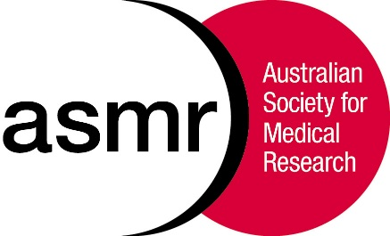
The Australian Society for Medical Research

ASMR Medical Research Week® May 30 – June 7 2019

MEDIA RELEASE – Friday 31st May, 2019

A SHOWCASE OF SYDNEY’S BEST AND BRIGHTEST SCIENTISTS
The Annual ASMR NSW Scientific Meeting happening now!
NSW Teacher’s Federation Conference Centre, 37 Reservoir St, Surry Hills

A new link discovered between the immune system and obesity
Obesity is a global problem. Beige fat can be harnessed for burning rather than storing fuel. New data from Dr Kate Quinlan’s lab at UNSW Sydney, has identified that signals from a special immune cell – the eosinophil – convert normal fat into beige fat. Discovering the exact signals that eosinophils produce could lead to therapeutic targets to create beige fat and combat obesity.

An old solution for a new problem: treating anti-biotic resistance
We urgently need alternative treatments to fight antibiotic resistance. Aleksandra Petrovic Fabijan was part of the Iredell phage team who treated critically ill patients with sepsis at Westemad hospital using adjunctive bacteriophage therapy. This type of therapy was well-tolerated and could be a potentially effective weapon in the fight against antibiotic resistance.

Nanoparticle drug delivery to the brain!
A unique natural protective cellular barrier separates our brain from the rest of the body, preventing toxic chemicals and molecules from entering the brain. But, this hampers drug delivery to the brain when we need it. Dr Bingyang Shi, leader of the Brain Drug Delivery at Macquarie University, has successfully developed a library of blood brain barrier penetrative delivery systems. He is using nanoparticles-based strategies to transport the drugs across the brain barrier and to the specific regions of the brain for effective brain disease therapy. This state-of-art nanotechnology could offer new solutions for fatal diseases like brain cancer, and Alzheimer’s disease.

Are e-cigarettes safe during pregnancy?
There is a perception that electronic cigarettes (e-cigarette) are a safe alternative to smoking tobacco cigarettes during pregnancy. But, there is little evidence to support this. A new study by Tara Nguyen at the University of Technology, Sydney, compared tobacco versus e-cigarette exposure during pregnancy in mice. The results show that cigarette smoke had a more marked effect on offspring neurology which were changed by switching to e-cigarettes, but not all, and not to normal levels.

Plenary Speaker: Professor Sally Dunwoodie, (Head of Embryology Laby, Victor Chang CRI)
Professor Dunwoodie is a world renowned congenital heart disease researcher. Among numerous other accolades, she won the 2018 Eureka Prize for Scientific Research for her breakthrough research on the potential of vitamin B3 to treat molecular deficiencies for prevention of miscarriages and birth defects. Professor Dunwoodie was also recently awarded a NHMRC Research Excellence Award for the highest ranked Project grant in 2018.
Media contacts: Dr Emily Colvin on 0410 475 509 or Cath West 0415 928 211
Interview and photo opportunities
Award presentations, including the prestigious NSW Office for Health and Medical Research Post-doctoral Research Award for Excellence in HMR, at the conclusion of the meeting from 5pm

