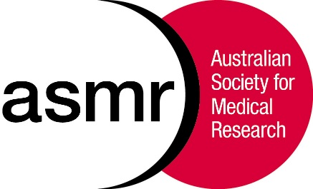
The Australian Society for Medical Research
ASMR Medical Research Week® May 30th – June 8, 2018

Media Alert – May 25th 2018

The ASMR Queensland Health & Medical Research Awards are
proudly supported by the Queensland Government

Finalists judging taking place today at the Translational Research Institute

WINNERS OF THESE PRESTIGIOUS AWARDS WILL BE ANNOUNCED AT THE
ASMR MEDICAL RESEARCH WEEK® GALA DINNER ON
FRIDAY THE 1ST OF JUNE AT HILLSTONE ST LUCIA, BRISBANE

2018 ASMR Queensland Health & Medical Research Award Finalists:

Clinical Researcher:
Dr Patrick Harris,
UQ Centre for Clinical Research
Professor John Fraser,
The Prince Charles Hospital
Dr Lisa Gillinder,
Mater Centre for Neurosciences

Mid-Career Researcher:
Dr Muhammad Shiddiky,
Griffith University
Dr Michael Smout,
James Cook University
Dr Conan Wang,
The University of Queensland

Early-Career Researcher:
Dr Kyohei Nakamura, QIMR Berghofer Medical Research Institute
Dr Kirsty Short,
The University of Queensland
Dr Tania Rivera Hernandez,
The University of Queensland

Postgraduate Student Researcher:
Ms Katie Lineburg, QIMR Berghofer Medical Research Institute
Dr Philip Mosley, QIMR Berghofer Medical Research Institute
Mr Kosala Weerakoon, QIMR Berghofer Medical Research Institute

Cutting edge research across cardiac disease, epilepsy, infectious diseases, nanoparticles based molecular diagnostics, wound healing, peptide therapeutics, myeloma, obesity,
stem cells, Parkinson’s disease

Finalists bios and scientific abstracts are available for download from

https://asmr.org.au/wp-content/uploads/2018/05/2018_ASMR_Awards_Booklet.pdf

Proudly supported by:
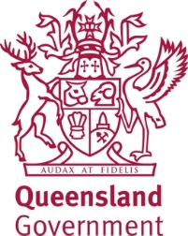

For further information contact:
Fernanda Caldas Cardosa 0401 822 108
or Catherine West 0415 928 211

