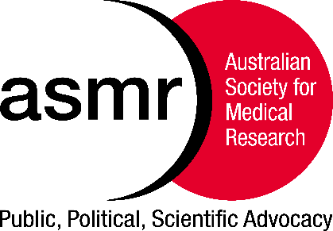
The Australian Society for Medical Research

Media Alert
11th November 2020

ASMR South Australia – Annual Scientific Meeting
The Ross Wishart Memorial Award, inaugurated in 1995, recognises the significant contributions of Ross Wishart to medical research and to the Society.
The Award is presented annually for the most outstanding presentation by a young researcher at the ASMR SA Annual Scientific Meeting

The Winner of this Prestigious Award was announced yesterday afternoon at the Meeting

Congratulations to Sarah Bernhardt, The Queen Elizabeth Hospital and Robinson Research Institute, University of Adelaide

Sarah’s research focuses on improving precision medicine for young breast cancer patients. Increasingly, clinicians are using genomic tests to determine the best treatment strategy for individual patients.

However, young women have been under-represented in clinical trials, and there are concerns surrounding the use of such tests for guiding treatment decisions in young women.

Sarah’s research focuses on this issue, taking a world-first approach to investigate how genomic tests are affected by patient age and menstrual cycle stage.

Her research will ensure that young women are not missing out on the exciting future of precision medicine.

On receiving the award, Sarah said, “I am incredibly honoured to have received this award and would like to congratulate all the finalists who gave their presentations today”.

Media contact: Khalia Primer 0437 147 809 or Catherine West 0415 928 211

