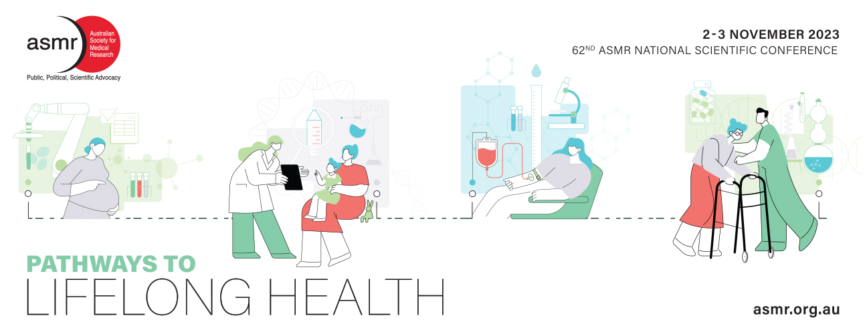
The ASMR welcomes submission of abstracts for consideration as oral or poster presentations at the 62nd ASMR National Scientific Conference. Please follow the guidelines below when preparing your abstract. As abstract submission is part of the registration process, please have your abstract ready to upload at the time of registration.
Abstracts can nominate in the following categories:
- Oral presentation
- Poster presentation
- Either an oral or poster presentation

We welcome abstracts from across the health and medical research sector but especially those that align with the broad session themes of the conference are:
- Paediatric and congenital diseases
- Maternal and prenatal health
- Cardiometabolic diseases
- Chronic diseases
- Cancer
- Healthy aging
- Neurodegenerative diseases
- Public health
- Other

Presentation preference will be accommodated where possible. However, in lodging an abstract submission the author accepts presentation style allocated by the Programming Committee. Authors will be notified by email of abstract acceptance and type of presentation.

Abstract submissions will close on September 15th, 2023

Early-bird registration will close on 15th September and final registrations will close on 1st November. Online registration and details are available at https://asmr.org.au/asmr-nsc/nsc-welcome/

Awards and eligibility:
There are several award opportunities available at the ASMR NSC, but all require eligibility criteria to be met.
You must be an ASMR member or have applied for membership prior to submission of your abstract to be considered for any of the awards

ASMR Membership:
Benefits of being an ASMR member include advocacy for health and medical research, professional development and networking opportunities, support for students and ECRs, and free/discounted registration for Medical Research Week® events and conferences around Australia. Apply for membership online here: https://asmr.org.au/membership/how-to-join/ If you require assistance in finding a current ASMR member to nominate you, please contact the ASMR executive office: asmr@asmr.org.au.

Awards will be judged by a panel of researchers for the clarity of presentation, the quality of data, the relevance of your work to your hypothesis and a clear demonstration of the importance of your work to health and medical research and the community.

- Best Oral Presentation (Postgraduate and EMCR categories)
- Best Poster Presentation (Postgraduate and EMCR categories)
- The Campion Ma Playoust Memorial Award is presented for the overall best presentation (oral or poster) at the National Scientific Meeting by a student member or a member under thirty years of age at the time of the meeting (determined via ASMR membership records).
- ASMR Peter Doherty Leading Light Award celebrates the achievements of a mid-career researcher (5 – 12 year post-doctoral). The award will consider a single piece of work undertaken within the past 5 years (i.e., after September 22nd 2018). Applications for this award are assessed separately and application forms can be found on the ASMR website.

Want to attend but don’t want to submit an abstract? Registration for the 62nd ASMR National Scientific Conference is possible without submitting an abstract. Simply fill out the registration form located online (https://asmr.org.au/asmr-nsc/nsc-welcome/) and select “no” when asked if you are submitting an abstract.

Want to submit more than one abstract? Once you have completed your online registration and uploaded one abstract, simply email your second (or more) abstract(s) to is nsc1@asmr.org.au with the subject line: 'ASMR NSC Additional Abstract Submissions' by the deadline. In your email and abstract document, please include the registration number that was provided to you at the completion of your online registration.

INSTRUCTIONS TO AUTHORS

All abstracts are to be uploaded online at the time of NSC Registration, using the document template below. Online registration and details are available at https://asmr.org.au/asmr-nsc/nsc-welcome/
Abstract submissions close September 15th, 2023

Abstract preparation: To submit an abstract please complete the templates on pages 4-6. Please DO NOT change margins or text formatting in any way. If changed, your abstract will be ineligible for selection.

Files should be saved as a word document (.docx) and labelled: first author’s last name, first name initial and presentation preference, e.g. Smith_J_oral; Smith_J_poster; Smith_J_either

Abstract Preparation:
- Please use the abstract template below. Please DO NOT CHANGE margins, spacing or text formatting.
- The title of the abstract is limited to 250 characters (including spaces).
- Titles should be typed in bold and at the top of the abstract.
- Font to be used is Arial at size 11 pt.
- Author’s names should be under the title, with the name of the presenting author in bold and underlined e.g., John Smith, Jane Jones, Jenny James…The authors listed on the abstract submission document must match the authors that are entered into the NSC registration portal.
- Institutions should be under the author’s names. No more than 3 institutions may be listed. Please cross-reference authors to their affiliations using superscript consecutive numbers following the author name and preceding the institute affiliation.
- The abstract body is limited to 300 words (not including title, authors and institutions).
- Abstracts longer than 300 words (not including spaces) will be truncated.
- The abstract should contain the following headings: Background and Aims, Methods, Results, Conclusions and Significance/Impact.
- Referencing is not required.
- The significance/impact of the work to health, medical research and the community should be highlighted, including the innovative aspects of the work.

Lay summary:
- A lay title and summary of your abstract should be provided to assist with abstract marking and for release to media if you receive an award. Please avoid the use of technical terms, abbreviations and acronyms.
- The lay title is limited to 100 characters (including spaces).
- The lay summary of your abstract is limited to 100 words.

Checklist:
Your saved file for upload must contain:

- Completed selections on page 4
- Your abstract using the provided template on page 5
- Your lay summary using the provided template on page 6
- Please delete the instruction pages (1-3) before uploading your file.

All enquiries regarding abstract submission should be directed to the ASMR Executive Officer: katriona@asmr.org.au

Please nominate 1 category that best fits your submitted abstract:
Paediatric and/or congenital diseases
Maternal and/or prenatal health
Cardiometabolic diseases
Chronic diseases
Healthy aging
Cancer
Neurodegenerative diseases
Public health
Other

Please nominate 2-5 subject areas relevant to your submitted abstract:
Aged care  Allied health  Animal models  Biochemistry  Bioinformatics  Biomarker research  Biotechnology  Cardiovascular research  Cancer  Cell biology  Clinical research  Commercialisation  Computational biology and/or statistics  Consumer advocacy  Dentistry  Developmental biology  Drug discovery  Drug target identification and validation  Education and training  Endocrinology  Environment  Epidemiology  Genetic counselling  Genetics, epigenetic or small RNAs  Healthcare | Health economics  Health policy  Health promotion  Imaging and computing  Immunology  Indigenous health  Industry  Invisible illnesses  Medicinal chemistry  Microbiology  Molecular biology  Neuroscience  Nutrition  Pain management  Pathology  Personalised Medicine  Rare diseases  Physiology  Psychology  Public health  Reproductive biology  Technology  Tele-health  Virology  Other (please specify):

Full Title Here Type Full Title Here Type Full Title Here Type Full Title Here Type Full Title Here Type Full Title Here Type Full Title Here (250 characters max.)

First Name Last Name¹, First Name Last Name², First Name Last Name³, First Name Last Name, First Name Last Name, First Name Last Name.

¹Type affiliations here.
²Type affiliations here.
³Type affiliations here.

Background and Aims: Type abstract here. Type abstract here. Type abstract here. Type abstract here. Type abstract here. Type abstract here. Type abstract here. Type abstract here. Type abstract here. Type abstract here. Type abstract here. Type abstract here. Type abstract here. Type abstract here. Type abstract here. Type abstract here. Type abstract here. Type abstract here. Type abstract here. Type abstract here. Type abstract here. Type abstract here. Type abstract here. Type abstract here. Type abstract here. Type abstract here. Type abstract here. Type abstract here.
Methods: Type abstract here. Type abstract here. Type abstract here. Type abstract here. Type abstract here. Type abstract here. Type abstract here. Type abstract here. Type abstract here. Type abstract here. Type abstract here. Type abstract here. Type abstract here. Type abstract here. Type abstract here.
Results: Type abstract here. Type abstract here. Type abstract here. Type abstract here. Type abstract here. Type abstract here. Type abstract here. Type abstract here. Type abstract here. Type abstract here. Type abstract here. Type abstract here. Type abstract here. Type abstract here. Type abstract here. Type abstract here. Type abstract here. Type abstract here. Type abstract here. Type abstract here. Type abstract here. Type abstract here. Type abstract here. Type abstract here. Type abstract here. Type abstract here. Type abstract here. Type abstract here. Type abstract here. Type abstract here. Type abstract here. Type abstract here. Type abstract here. Type abstract here. Type abstract here. Type abstract here.
Conclusions and Significance/Impact: Type abstract here. Type abstract here. Type abstract here. Type abstract here. Type abstract here. Type abstract here. Type abstract here. Type abstract here. Type abstract here. Type abstract here. Type abstract here. Type abstract here. Type abstract here. Type abstract here. Type abstract here. Type abstract here. Type abstract here.

(300 words max.)

Lay Title: Type Lay Title Here Type Lay Title Here Type Lay Title Here Type Lay Title Here (100 characters max.)

First Name Last Name¹ of first author.

¹Type affiliation of first author here.

Lay Summary: Type lay summary here. Type lay summary here. Type lay summary here. Type lay summary here. Type lay summary here. Type lay summary here. Type lay summary here. Type lay summary here. Type lay summary here. Type lay summary here. Type lay summary here. Type lay summary here. Type lay summary here. Type lay summary here. Type lay summary here. Type lay summary here. Type lay summary here. Type lay summary here. Type lay summary here. Type lay summary here. Type lay summary here. Type lay summary here. Type lay summary here. Type lay summary here.

(100 words max.)

