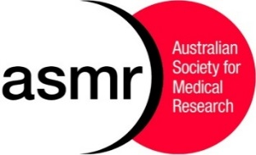
Australian Society for Medical Research

APPLICATION FOR STUDENT TRAVEL SUBSIDY
for
the ASMR 62nd National Scientific Conference

ASMR offers student travel subsidies to reduce eligible student members’ costs of travel to the NSC.
NOTE: The value of the subsidy will be based on the number of eligible applicants and the cheapest airfares to Melbourne available for the dates of the NSC. The subsidy will be paid by direct deposit during the NSC.

STUDENT DETAILS

SURNAME
FIRST NAME
MR MS MRS MISS
PROFESSIONAL ADDRESS (PLEASE INCLUDE DEPARTMENT & INSTITUTE)

STATE P/CODE

TELEPHONE (M) ...................

EMAIL

COURSE

SUPERVISOR

I apply for the ASMR Student Travel Subsidy for the ASMR National Scientific Conference on the grounds that:
Tick to confirm
a. I am a full-time student member of ASMR;
b. I will earn less than $30,000 in the current calendar year; and
c. I have paid all of my travel to the conference from my own funds.

Signed……………………………………………………………. Date………………………………..
COMPLETED FORM MUST BE SUBMITTED TO katriona@asmr.org.au
NO LATER THAN 5pm ON FRIDAY OCTOBER 27th.

