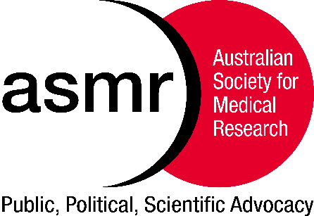**The Australian Society for Medical Research**

**Alan Skyring Memorial Award**

**Information for Applicants**

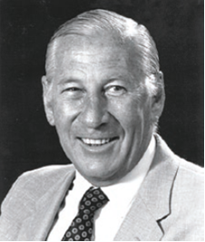In 1960, after spending 2 years in the United States,   
Dr Alan Skyring and Dr Barry Firkin arrived back in Australia to take up the positions of Director of Gastroenterology and Director of the Clinical Research Unit, respectively, at the Royal Prince Alfred Hospital in Camperdown. At the time, both felt existing societies in Australia were inadequate for the growing needs of health and medical researchers. Thus, influenced by their time in America, they followed the example of the American Federation for Clinical Research (which showcased multidisciplinary research and fostered young investigators) and formed the Australian Society for Medical Research (ASMR) in 1961. Barry Firkin became the first President of the ASMR, while Alan Skyring became the first Secretary/Treasurer. In its first year, Dr Skyring was tasked with raising money, organising the first Annual General Meeting and publishing the Journal titled “Medical Research”. The following year, in 1962, Skyring succeeded Firkin as the second President of the ASMR.

**Dr Alan Skyring   
Co-founder of the ASMR**

The Alan Skyring Memorial Award was proposed by the members of the ASMR New South Wales Committee in December 2018 after Dr Skyring passed away at the age of 92. The award is in recognition of Dr Skyring’s significant contributions to health and medicine and the ASMR. The Award will be presented annually to a mid-career investigator for the most outstanding presentation at the ASMR NSW Annual Scientific Meeting.

To nominate for the award, please follow the instructions to authors, using the template provided on the following pages for the Abstract, CV, and supporting statement. Applications will be scored by independent assessors relative to opportunity based on the following criteria:

* Quality of the abstract
* CV (MUST USE THE CV TEMPLATE BELOW, include information from the last 10 years)
* Significance, context and impact of your work to health and medicine and influence on field

Three finalists will be selected to give an 8-minute presentation followed by Q & A to a general scientific audience at the ASMR NSW 2024 Annual Scientific Meeting. All other abstracts will be considered for Oral or Poster presentations.

APPLICATIONS CONTAINING A CV GREATER THAN TWO PAGES **WILL NOT** BE CONSIDERED FOR THE AWARD. YOU MUST USE THE CV TEMPLATE AND THE FONT IS TO BE 11 POINT ARIAL.

**Alan Skyring Memorial Award**

**CV**

**Name and Title:**

**Institution:**

**Summary of research area (no more than 100 words):**

**Qualifications and year awarded:**

**Summarise your publications and metrics for the last ten years**

**(e.g. total number, number first and last author, total cites, etc.):**

**Summarise oral conference presentations for the last ten years**

**(number international/national, indicate if invited or selected from abstract):**

**Summarise awards, prizes and distinctions for the last ten years:**

**Contribution to the Scientific Community**

**(e.g. Conference organisation, public outreach, committees):**

**Professional Society Membership:**

**Please supply the name and contact details of ONE referee:**

**Supporting statement - Outline in 250 words or less why you should receive this award) Include significance, context and impact of your work to health and medicine and how it has influenced your field):**