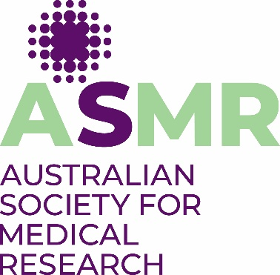

**APPLICATION FOR**

**ASMR STUDENT TRAVEL SUBSIDY**

to attend the

**63rd ASMR National Scientific Conference**

**21-22 November 2023 in Adelaide**

**ASMR is offering TWO student travel subsidies to reduce eligible student members’ costs of travel to the ASMR National Scientific Conference in Adelaide.** These subsidies include accommodation on Monday 21 October at a hotel of ASMR’s choosing in Adelaide plus up to $500 towards a return flight to Adelaide. The airfare component of your subsidy will be paid by direct deposit upon presentation of your flight eTicket at the Registration Desk during the NSC.

**STUDENT DETAILS**

SURNAME

FIRST NAME

DR MR MS MRS MISS

PROFESSIONAL ADDRESS (PLEASE INCLUDE DEPARTMENT & INSTITUTE)

STATE P/CODE

TELEPHONE (M) ...................

EMAIL

COURSE

SUPERVISOR

**I apply for the ASMR Student Travel Subsidy for the ASMR National Scientific Conference on the grounds that:**

Tick to confirm

I am a full-time student member of ASMR and have had an abstract accepted at this meeting;

I receive a student stipend and my total income will not exceed $50,000 in the current calendar year; and

I have paid all of my travel to the conference from my own funds.

Signed……………………………………………………………. Date………………………………..

**COMPLETED FORM MUST BE SUBMITTED TO katriona@asmr.org.au**

**NO LATER THAN 5pm ON FRIDAY 11 OCTOBER 2024.**